Assignment 6: Solution

Routing using RIP Version 2 (Cisco Packet Tracer)

Objective
To configure and verify routing using RIP Version 2 protocol in a network.

Problem Statement
Design and implement the given network topology in Cisco Packet Tracer with three routers (R1, R2, R3), two LANs, and PCs using the provided IP addressing scheme.
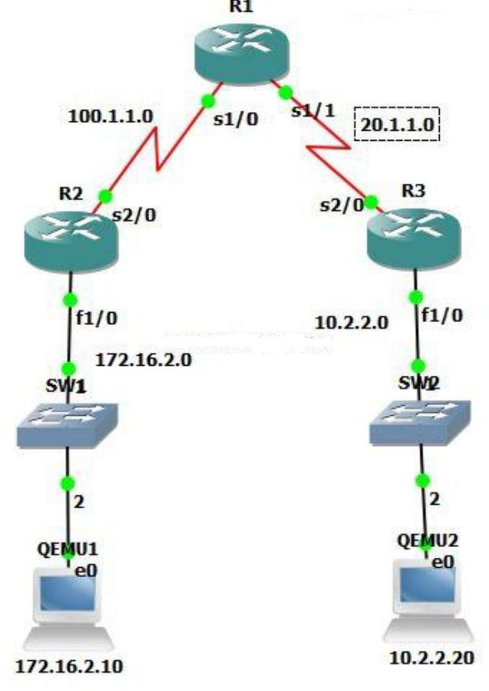

Network Details
Device | Interface | IP Address | Subnet Mask
R1 | S0/0/0 | 100.1.1.2 | 255.255.255.0
R1 | S0/0/1 | 20.1.1.1 | 255.255.255.0
R2 | S0/0/0 | 100.1.1.1 | 255.255.255.0
R2 | G0/0 | 172.16.2.1 | 255.255.0.0
R3 | S0/0/1 | 20.1.1.2 | 255.255.255.0
R3 | G0/0 | 10.2.2.1 | 255.255.255.0
PC1 | NIC | 172.16.2.10 | 255.255.0.0
PC2 | NIC | 10.2.2.20 | 255.255.255.0
Tasks
- Create the network topology in Cisco Packet Tracer.
- Configure IP addresses on all router interfaces and PCs.
- Enable RIP Version 2 routing on all routers.
- Advertise all directly connected networks using RIP.
- Disable auto-summary in RIP configuration.
- Verify routing tables using 'show ip route'.
- Test connectivity by pinging PC2 from PC1 and between routers.

Router Configurations
R1 Configuration:
enable conf t
interface s0/0/0
ip address 100.1.1.2 255.255.255.0
clock rate 64000 no shutdown interface s0/0/1
ip address 20.1.1.1 255.255.255.0 no shutdown
router rip version 2
no auto-summary

network 100.1.1.0
network 20.1.1.0 end
R2 Configuration:
enable conf t
interface s0/0/0
ip address 100.1.1.1 255.255.255.0
no shutdown interface g0/0
ip address 172.16.2.1 255.255.0.0 no shutdown
router rip version 2
no auto-summary network 100.1.1.0
network 172.16.0.0 end
R3 Configuration:
enable conf t
interface s0/0/1
ip address 20.1.1.2 255.255.255.0 no shutdown
interface g0/0
ip address 10.2.2.1 255.255.255.0 no shutdown
router rip version 2
no auto-summary network 20.1.1.0
network 10.2.2.0 end

Solution

